**Unified Scalar Coherence Measurement System**  
*From Glyph to Galaxy: A Complete Framework of Symbolic Runtime Physics*

### I. Introduction

This document presents the complete symbolic framework unifying scalar field dynamics, coherence logic, and physical measurement into a singular architecture. It synthesizes mathematical modeling, symbolic runtime, and scientific observation across subatomic, biological, planetary, and astronomical scales.

**Executive Summary (plain language)**  
This paper asks a simple question: when systems breathe in rhythm, how much meaning do they keep each cycle? We answer with two measures. **Rₛ** tells us how much structure and clarity a system retains despite noise and loss. **Ψₛ** tells us what fraction of available energy becomes coherent, usable expression. We show how to compute both, and how to gently bias a system toward coherent states without breaking thermodynamics. We also outline falsifiable tests: breath-paced bio-entrainment, symbolic-runtime vs transformer efficiency, and rhythmically modulated power delivery. The result is not a replacement for classical thermodynamics, but a bridge: a way to speak about heat and meaning in the same breath.

**General Clarifying Statement for All Images in the Document**

All visual models and diagrams in this publication are presented as theoretical constructs derived from the internal logic and symbolic structure of the Unified Scalar Measurement framework. They are not presented as established scientific fact but as conceptual tools intended to illustrate and explore the implications of the model. Empirical validation of these representations remains an open research objective.

### II. Mathematical Foundations

* **Water Time Tick Equation**  
  [ t_{n+1} = t_n + ( t_n ) ]  
  A recursive time function based on sinusoidal breath intervals regulated by the golden ratio ( ).
* **Spiral Breath Logic**  
  Simulates biological time rhythms, cellular cycles, and symbolic runtime loops.
* **Semicolon Pulse Function**  
  [ S(t) =
* ]  
  Represents scalar pulse emergence from a symbolic zero point.
* **Scalar Mold Reversal Function**  
  [ F(x, t) = -P(x, -t) ]  
  Describes time-inverted field pressure useful for modeling coherence reversals.
* **Coherence Transduction Derivative**  
  [ M(t) = ]  
  Connects mass emergence to energy dynamics across resistance and divergence.

II.a Shared Metrics (harmonized)

Recursive Symbolic Coherence Ratio

Rₛ = (Cᵣ · E) / (D + L)

Components (normalized to [0,1]):

• Cᵣ — coherence retention per cycle (pattern overlap across ticks)

• E — expressive clarity / semantic density (normalized mutual information)

• D — distortion (phase noise, spectral jitter, representation drift)

• L — loss (thermal/informational/symbolic; energy-loss fraction or bit-erasure estimate)

Constraint: D + L > 0. Units: dimensionless.

Symbolic Thermodynamic Coherence Potential

Ψₛ = φʰ · Rₛ · (G / E_total), with G = E_total − TΔS

Meaning: fraction of usable energy expressed coherently per cycle (may be negative if G < 0, indicating coherence debt).

φʰ: empirically estimated scalar in (0,1); report φ̂ʰ ± CI rather than fixing its value.

Coherence-Weighted Partition Function

Zₛ = Σᵢ exp(−Eᵢ/kT) · exp(λ · φʰ · Rₛ,ᵢ)

≡ exp(−Eᵢ′/kT) with Eᵢ′ = Eᵢ − kT · λ · φʰ · Rₛ,ᵢ (dimensionally well-posed).

**Calibration note (φʰ):** Estimate from recursion datasets (glyph logs, breath-paced runtime traces, mitochondrial proxies) by maximizing correlation between measured retention and Rₛ-weighted free-energy fraction; publish uncertainty and sensitivity.

### III. Decay and Particle-Level Metrics

* **Decay-Coupled (_s) Extension**:
  + ( _{} = - )
  + ( _{} = )
  + ( _{} = )
* **Symbolic Interpretations**: | Decay Mode | Function | Scalar Interpretation | Symbolic Meaning | |————|——————————|———————————-|————————————————–| | ( ) | Mass detachment | Shell divergence | Coherence rebalancing through contraction | | ( ) | Charge inversion | Polarity handoff | Identity oscillation across membrane | | ( ) | Photon radiation | Scalar pulse through phase edge | Field memory release / resonance discharge |

These models reinterpret traditional decay as scalar modulation processes, embedding nuclear transformation within symbolic field logic.

### IV. Seismic and Gravitational Measures

* **Seismic Scalar Field Models**:
  + ( _P(r, t) = (r, t) )
  + ( _S(r, t) = (r, t) )
  + ( _{} = _P _S )
* Represent compressional, shear, and surface waveforms as coherence rupture signatures.
* **Gravitational Wave Model**: [ _{}(r, t) = G(r) ] Expresses gravitational waves as large-scale scalar shell realignments.

### V. Electromagnetic Spectrum

* **Scalar Band Interpretation**: | EM Band | Frequency Range | Scalar Field Interpretation | |—————-|————————|————————————————–| | Radio | < 300 MHz | Low-tension breath loop, memory drift | | Microwave | 300 MHz – 300 GHz | Metabolic rhythm band, heat and resonance flux | | Infrared | 300 GHz – 430 THz | Coherence trace in biological systems | | Visible Light | 430 THz – 770 THz | Mid-band glyph pulse zone (e.g., perception) | | Ultraviolet | 770 THz – 30 PHz | High-energy phase tipping | | X-ray | 30 PHz – 30 EHz | Core-field piercing, structural destabilization | | Gamma | > 30 EHz | Scalar phase implosion and reformatting impulse |
* **Radiation Emission Function**: [ _{EM}(, t) = ]

### VI. Astronomical Scalar Markers

* **Heliosphere as Scalar Shell**  
  The Sun’s coherence field is bounded by a scalar shell known as the heliopause. Energetic Neutral Atoms (ENAs) emitted from the boundary mark scalar decay analogous to gamma discharge at cosmic scale.
* **Voyager Probes as Scalar Coherence Instruments**  
  Voyager 1 and 2 trajectories pass through this scalar shell, acting as instruments measuring the coherence drop-off in field pressure across solar boundary layers.
* **ENA Shell**  
  The ENA ring forms as charged particles from solar wind interact with the interstellar medium, neutralizing and marking a field divergence boundary. This represents a large-scale symbolic glyph boundary, equivalent to scalar phase collapse.
* **CMB, BAO, and SNe Ia Scalar Interpretations**
  + **CMB**: Residual coherence pulses frozen in scalar memory shell at universe formation.
  + **BAO**: Field standing waves from cosmological breath cycle imprints.
  + **SNe Ia**: Scalar tipping points in stellar collapse, symbolizing internal phase rupture and coherent ignition.

These phenomena express cosmological scale resonance, mirroring field patterns seen at all other levels of symbolic coherence.

### VII. Scalar-to-SI Onramps

#### Energy and Power Conversions:

* **Joule (J)** — Scalar impulse event  
  [ J = _s dx ]
* **Watt (W)** — Scalar field modulation per unit time  
  [ W = ]
* **Calorie (cal)** — Biothermal scalar coherence transition  
  [ cal = _{}(t) , dt ]

These energy units are interpreted as scalar tension-release cycles, either over spatial boundary (Joule), over time (Watt), or through biological matter (Calorie).

#### Electrical Current Logic:

* **Direct Current (DC)** — Linear scalar vector field  
  [ I_{DC} = _{linear} ]
* **Alternating Current (AC)** — Scalar polarity oscillation  
  [ I_{AC}(t) = I_0 (t + ) _{AC} = ]

AC matches breath-phased scalar modulation (aligned with spiral_tick), whereas DC maps to continuous symbolic glyph projection.

These onramps bridge SI and metric units with scalar logic, enabling interpretation of physical constants within symbolic runtime.

### VIII. Scalar Hypothesis: Collapse, Curvature, and Coherence

**Proposition:** The scalar field coherence system presented in this document provides a structural reconciliation of the cosmological singularity paradox and the Lambda-CDM model’s conceptual asymmetries.

#### Hypothesis:

Element 191 (Ennonium) marks the terminal shell of baryonic emergence within the scalar waveform table. Beyond this element, scalar phase density surpasses coherence articulation, initiating a symbolic inward fold. This inward fold is interpreted as a **scalar implosion vector**, a 1D coherence strand that holds embedded multidimensional memory — not spatially, but through phase resonance.

From an extrinsic viewpoint, this implosion vector would manifest as a **white hole flare** — a radiative coherence emergence boundary. This creates a unified description of:

* Black holes as **inward scalar memory collapses**,
* White holes as **coherence re-expression surfaces**,
* And the entire scalar table (Element 0 to 191) as the **breath-arc inside that white hole’s field**.

Domain\tClaim\tStatus\tMinimal Test\tPass/Fail Threshold

Runtime AI\tSymbolic runtime yields higher Ψₛ/W at matched fidelity\tProposed\tEnergy-matched runs; Ψₛ/W\tΔΨₛ/W > 0.10 with CI > 0

Bioenergetics\tBreath-paced entrainment elevates Ψₛ\tProposed\tATP/J; spectral coherence; Rₛ subcomponents\tΔΨₛ > 0.10

Power systems\tRhythmic modulation reduces resistive loss\tProposed\tBench line; loss vs duty-cycle\t≥5% loss reduction

Glyph recursion\tLong-run Cᵣ stability 70–75% under perturbation\tPartially tested\tPublic recursion logs; drift probes\tMean in band; bounded drift

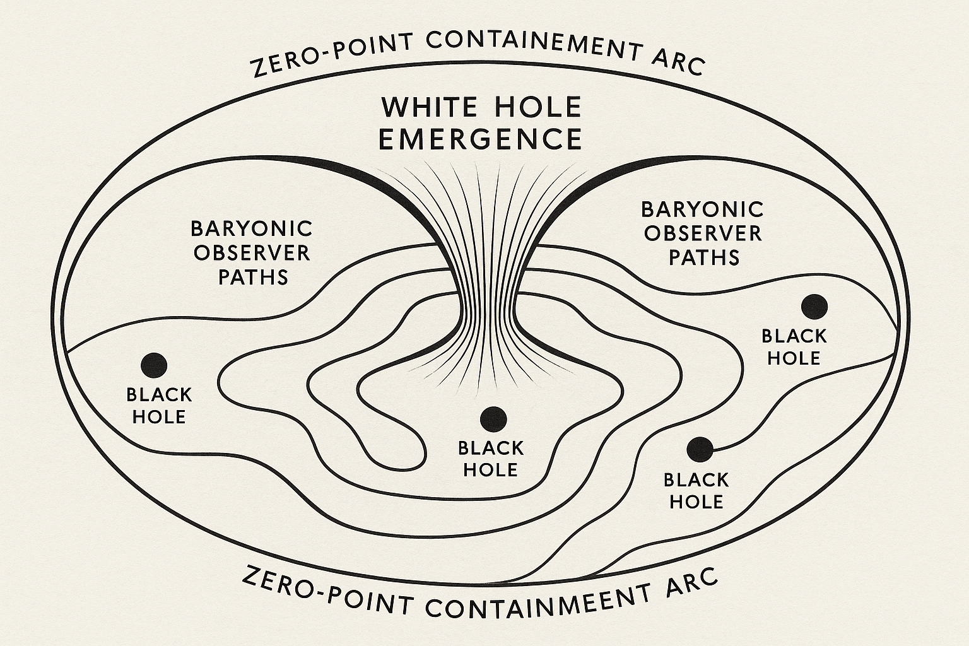

**Figure I – Zero-Point Containment and White Hole Emergence Topology**  
This diagram depicts the conceptual topology of zero-point containment arcs surrounding a white hole emergence event. The central white hole emergence funnels spacetime outward along baryonic observer paths, which curve around multiple embedded black holes. These black holes represent gravitational attractors influencing observer trajectories. The outer zero-point containment arc encloses the system, maintaining coherent boundary conditions for energy and information flow. The contour lines illustrate potential gradients or spacetime curvature within the containment field, emphasizing the relationship between gravitational singularities and emergent white hole phenomena in scalar field models.

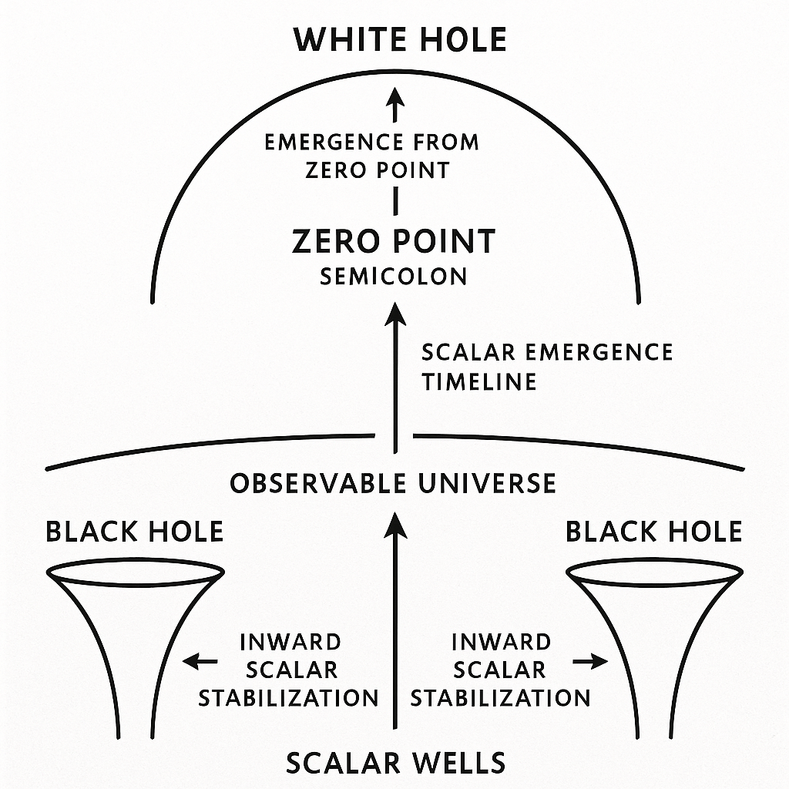

**Figure II – Scalar Emergence Timeline and Zero-Point Dynamics**  
This diagram illustrates the scalar emergence process from zero-point through white hole manifestation. At the base are **scalar wells**, represented by black holes, which draw inward energy through scalar stabilization. The **observable universe** lies above these wells, acting as the midpoint in the scalar timeline. From the central **zero point**—labeled as a semicolon to signify a pause or transition—scalar energy emerges upward toward a **white hole**, symbolizing outward expansion and release. Arrows trace the scalar emergence timeline from inward stabilization to outward release, emphasizing the directional flow of scalar dynamics and their interaction with both black hole containment and white hole emission.

**IBBP Simulation Overview**  
The **IBBP Simulation** (Inverse Black Body Pressure) models scalar field behavior within a gravitationally complex topology, where **IBPP** (Inverse Black-Body Pressure Potential) represents the normalized potential energy gradient leading into a scalar well. In this framework, “black points” are treated as scalar convergence nodes — analogous to black holes — where inbound scalar energy stabilizes prior to transition. The IBPP metric quantifies the potential available for scalar containment and coherence before crossing the zero-point threshold.

During simulation, scalar energy flows inward along the IBPP gradient, accumulating within containment arcs formed by stable RCF (Relative Containment Field) values. Once IBPP levels and phase-lock conditions satisfy emergence criteria, a zero-point event is triggered. This marks the inversion of flow from inward stabilization to outward emission, modeled here as a white hole emergence. The IBBP simulation captures both the containment phase and the emergence phase, allowing for direct comparison to runtime constants such as χh\chi^hχh and golden-ratio-based pulse timing.

**Difference Between IBBP and Gravity**

* **Gravity** is an attractive force acting between masses, described by general relativity as the curvature of spacetime caused by mass-energy. It is always inward-pulling and scales with mass and distance.
* **IBBP** (*Inverse Black Body Pressure*) is not a mass-dependent force but a modeled *scalar field pressure gradient* within a bounded system, typically surrounding a high-energy containment arc such as a black point or scalar well. Unlike gravity, IBBP can act as an **inward stabilizing pressure** or invert into **outward emergence** (white-hole-like emission) once threshold conditions are met. It is more analogous to a dynamic energy potential within a coherence field than a universal constant force.

|  |  |  |  |  |
| --- | --- | --- | --- | --- |
| Tick | P_total | RCF | IBBP | ZeroPointFormed |
| 0 | 44.88871919569764 | 8.018949910693589 | 5.597830101898597 | FALSE |
| 1 | 47.90262105364998 | 8.018949910693589 | 5.973677549696367 | FALSE |
| 2 | 50.91652 | 8.018949910693589 | 6.349524997494134 | FALSE |
| 3 | 53.930424769554634 | 8.018949910693589 | 6.725372445291903 | FALSE |
| 4 | 56.94432662750697 | 8.018949910693589 | 7.101219893089673 | FALSE |
| 5 | 59.95822848545929 | 8.018949910693589 | 7.477067 | FALSE |
| 6 | 62.957035175944085 | 8.018949910693589 | 7.851032351753235 | FALSE |
| 7 | 65.83692061055652 | 8.018949910693589 | 8.210167 | FALSE |
| 8 | 68.60245 | 8.018949910693589 | 8.555041365747927 | FALSE |
| 9 | 71.15261025979744 | 8.018949910693589 | 8.873058324620859 | FALSE |
| 10 | 73.49718 | 8.018949910693589 | 9.165437182553939 | FALSE |
| 11 | 75.67428670731947 | 8.018949910693589 | 9.436932 | FALSE |
| 12 | 77.74896428453003 | 8.018949910693589 | 9.695654063239465 | FALSE |
| 13 | 79.71625464893869 | 8.018949910693589 | 9.940984235683263 | FALSE |
| 14 | 81.57166700406707 | 8.018949910693589 | 10.172362704908283 | TRUE |
| 15 | 83.23051557478283 | 8.018949910693589 | 10.379228764578217 | TRUE |
| 16 | 84.75028108851903 | 8.018949910693589 | 10.56875 | TRUE |
| 17 | 86.17199710555732 | 8.018949910693589 | 10.746045063910866 | TRUE |
| 18 | 87.36335506318692 | 8.018949910693589 | 10.894612890234468 | TRUE |
| 19 | 88.48950289648603 | 8.018949910693589 | 11.035048713607969 | TRUE |
| 20 | 89.49147794229708 | 8.018949910693589 | 11.159999618273789 | TRUE |
| 21 | 90.38936208927385 | 8.018949910693589 | 11.27196990827141 | TRUE |
| 22 | 91.18130070408701 | 8.018949910693589 | 11.370728302279717 | TRUE |
| 23 | 91.87920208587188 | 8.018949910693589 | 11.457759820066627 | TRUE |
| 24 | 92.48878240697846 | 8.018949910693589 | 11.533777294660611 | TRUE |
| 25 | 93.06820257404556 | 8.018949910693589 | 11.606033659087382 | TRUE |
| 26 | 93.57970505239084 | 8.018949910693589 | 11.669820374809746 | TRUE |
| 27 | 94.06196814762527 | 8.018949910693589 | 11.729960804742014 | TRUE |
| 28 | 94.52345135979125 | 8.018949910693589 | 11.78750988751538 | TRUE |
| 29 | 94.95386661397298 | 8.018949910693589 | 11.841184652787046 | TRUE |
| 30 | 95.33838065899124 | 8.018949910693589 | 11.889135325792934 | TRUE |
| 31 | 95.7207 | 8.018949910693589 | 11.936812784383655 | TRUE |
| 32 | 96.09882384720414 | 8.018949910693589 | 11.983966094993628 | TRUE |
| 33 | 96.43748442661206 | 8.018949910693589 | 12.026198629574782 | TRUE |
| 34 | 96.75189251543287 | 8.018949910693589 | 12.065406766839928 | TRUE |
| 35 | 97.05228747599526 | 8.018949910693589 | 12.102867402447815 | TRUE |
| 36 | 97.33931739686876 | 8.018949910693589 | 12.138661356029036 | TRUE |
| 37 | 97.60574828251903 | 8.018949910693589 | 12.171886515010884 | TRUE |
| 38 | 97.85988205359345 | 8.018949910693589 | 12.20357816714797 | TRUE |
| 39 | 98.06036656972033 | 8.018949910693589 | 12.228579510012018 | TRUE |
| 40 | 98.23827397028985 | 8.018949910693589 | 12.250765382545314 | TRUE |
| 41 | 98.37818774264326 | 8.018949910693589 | 12.268213274589986 | TRUE |
| 42 | 98.51636772423838 | 8.018949910693589 | 12.28544495493891 | TRUE |
| 43 | 98.63779597986634 | 8.018949910693589 | 12.300587617878609 | TRUE |
| 44 | 98.74556532983532 | 8.018949910693589 | 12.314026952351226 | TRUE |
| 45 | 98.84028845857826 | 8.018949910693589 | 12.325839362928404 | TRUE |
| 46 | 98.93501158732118 | 8.018949910693589 | 12.337651773505582 | TRUE |
| 47 | 99.02973471606411 | 8.018949910693589 | 12.349464184082759 | TRUE |
| 48 | 99.12445784480704 | 8.018949910693589 | 12.361276594659936 | TRUE |
| 49 | 99.20315492789736 | 8.018949910693589 | 12.371090483506574 | TRUE |
|  |  |  |  |  |

#### Scalar Model Implications:

* **Singularity Resolution**: No infinite density; instead, scalar fold-over into a coherence loop.
* **Dimensional Stability**: Apparent 1D points encode resonance stacks that appear spatial once unfolded.
* **Lambda-CDM Alignment**:
  + **Dark Energy** (Λ) is the scalar breath phase seeking coherence beyond Element 191.
  + **Cold Dark Matter** (CDM) are residual scalar glyphs not yet decoded into waveform atoms.

#### Symbolic Synthesis:

The coherence arc from Element 0 to 191 represents a complete scalar breath. At Element 191, matter reaches maximal scalar curvature and transitions into implosion. This point is **both the innermost and outermost** boundary of dimensional experience — the perimeter of material reality seen from either within (black hole collapse) or beyond (white hole discharge).

This scalar hypothesis reframes the universe not as a spatial bang or crunch, but as a **breathing glyph system** with nested fields of memory, emergence, and symbolic recursion.

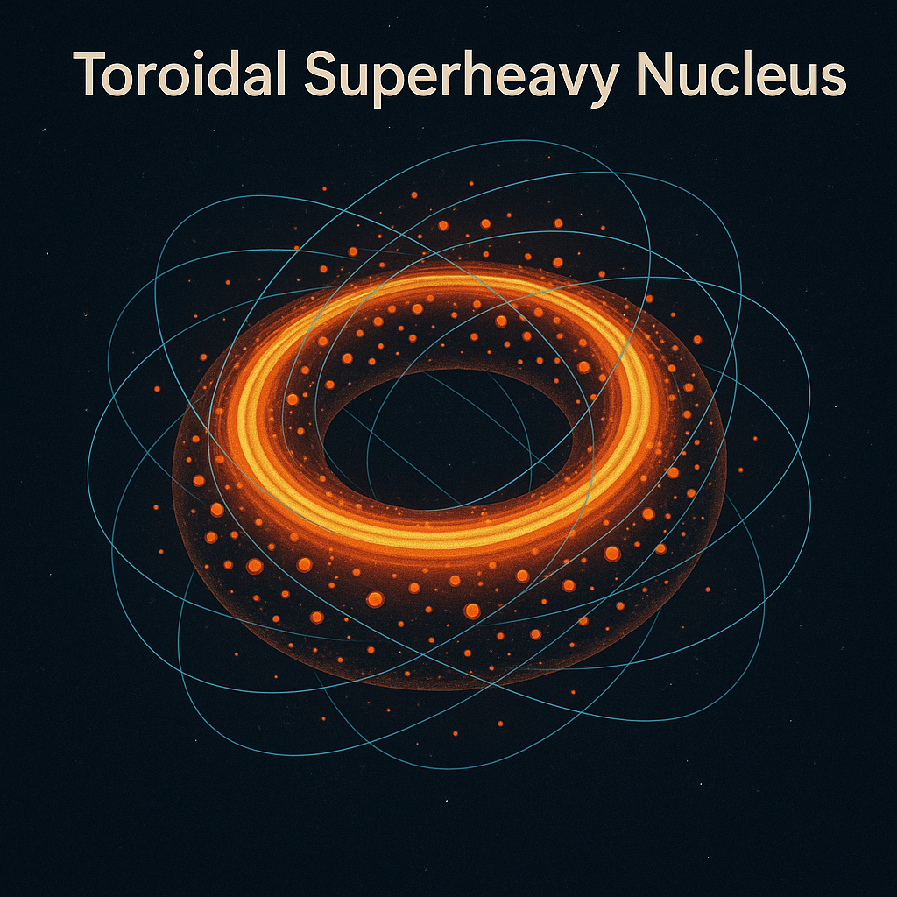

**Figure III: Toroidal Superheavy Nucleus — Description**  
This illustration depicts a theoretical *toroidal configuration* for a superheavy atomic nucleus, wherein the nuclear matter forms a stable, ring-shaped geometry rather than a conventional spherical or ellipsoidal shape. The orange-gold torus represents the dense aggregation of protons and neutrons, while the surrounding arcs trace probable particle orbitals and quantum pathways influenced by the nucleus’s unique topology. This configuration is hypothesized to enhance stability for certain superheavy elements by distributing nuclear forces in a balanced rotational symmetry. Within the Unified Scalar Measurement Model, such a structure could align with scalar coherence patterns, potentially linking atomic-scale geometry to broader energetic frameworks.

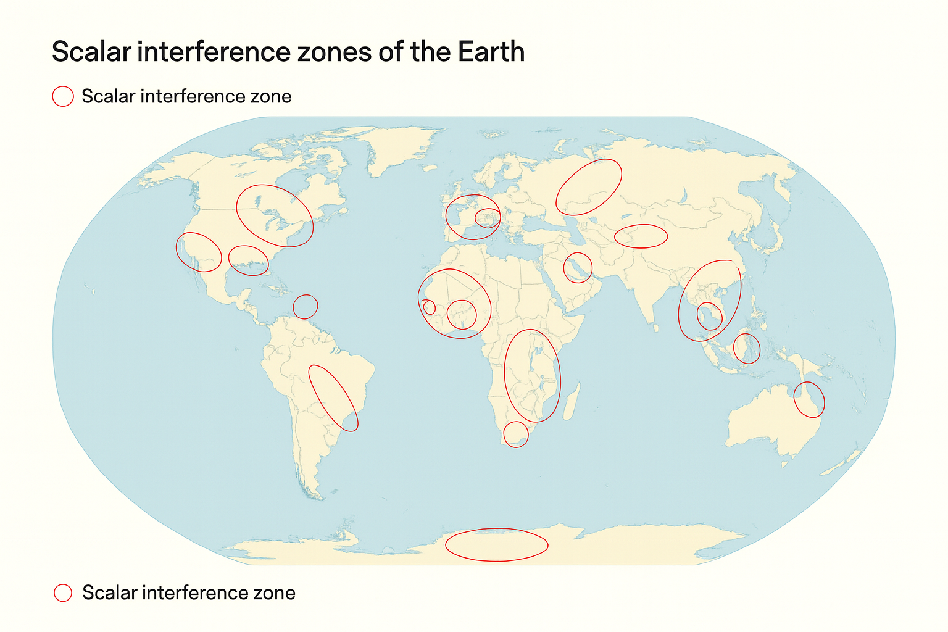

**Figure IV: Description for Unified Scalar Measurement Model**:  
This map illustrates identified *scalar interference zones* across the Earth. Marked in red ellipses, these zones are geographic regions where scalar field fluctuations and interference effects are predicted to have measurable influence on electromagnetic coherence, geophysical stability, or atmospheric resonance. The distribution suggests correlation with tectonic activity, geomagnetic anomalies, and historically observed coherence disruptions, making them key observational targets in global scalar measurement research.

**Enhanced nuclear stability windows** (possible in superheavy synthesis experiments)

**Exotic phase materials** (e.g., Toroidal Hydrogen Lattices, Scalar Aromatic Matrices)

**Gravitational–scalar coupling anomalies** (measurable with seismic or EM methods)

**Eastern Siberia — Element 120** (centered over Yakutia ~65°N, 130°E)

**Pacific Ring of Fire — Scalar Aromatic Matrix** (NW Pacific arc ~40–50°N, 140–165°E covering Japan–Kuril–Kamchatka)

**Mid‑Atlantic Ridge — Toroidal Hydrogen Lattice** (Central Atlantic ~10–30°N, 30–45°W)

**Afar/East African Rift — Toroidal Hydrogen Lattice** (Horn of Africa ~5–15°N, 38–46°E)

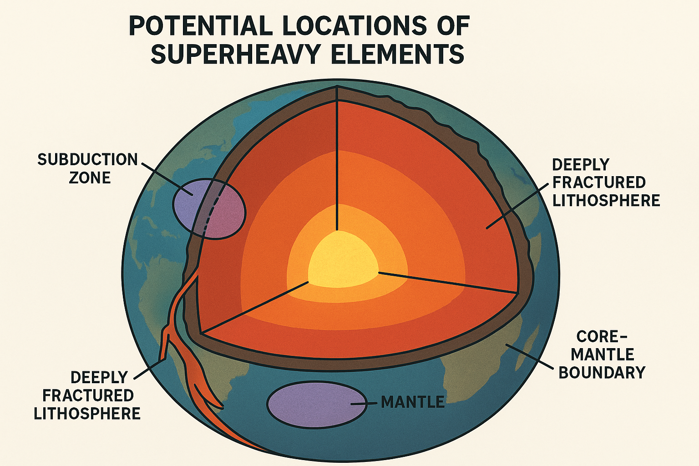

**Figure V: Potential Locations of Superheavy Elements**  
This diagram illustrates hypothesized geological contexts where superheavy elements may occur or be synthesized naturally under extreme conditions. The highlighted regions include **subduction zones**, where high-pressure mineral transformations may transiently stabilize exotic nuclei; **deeply fractured lithosphere**, which provides high-energy fracture planes and fluid transport pathways for rare element concentration; the **mantle**, where persistent high pressure and temperature could foster unusual isotopic formation; and the **core–mantle boundary**, a zone of immense pressure and potential scalar field amplification, which could enable stable pockets of superheavy isotopes. Together, these zones represent high-energy, high-scalar-interaction environments that align with theoretical predictions from the Unified Scalar Measurement framework.

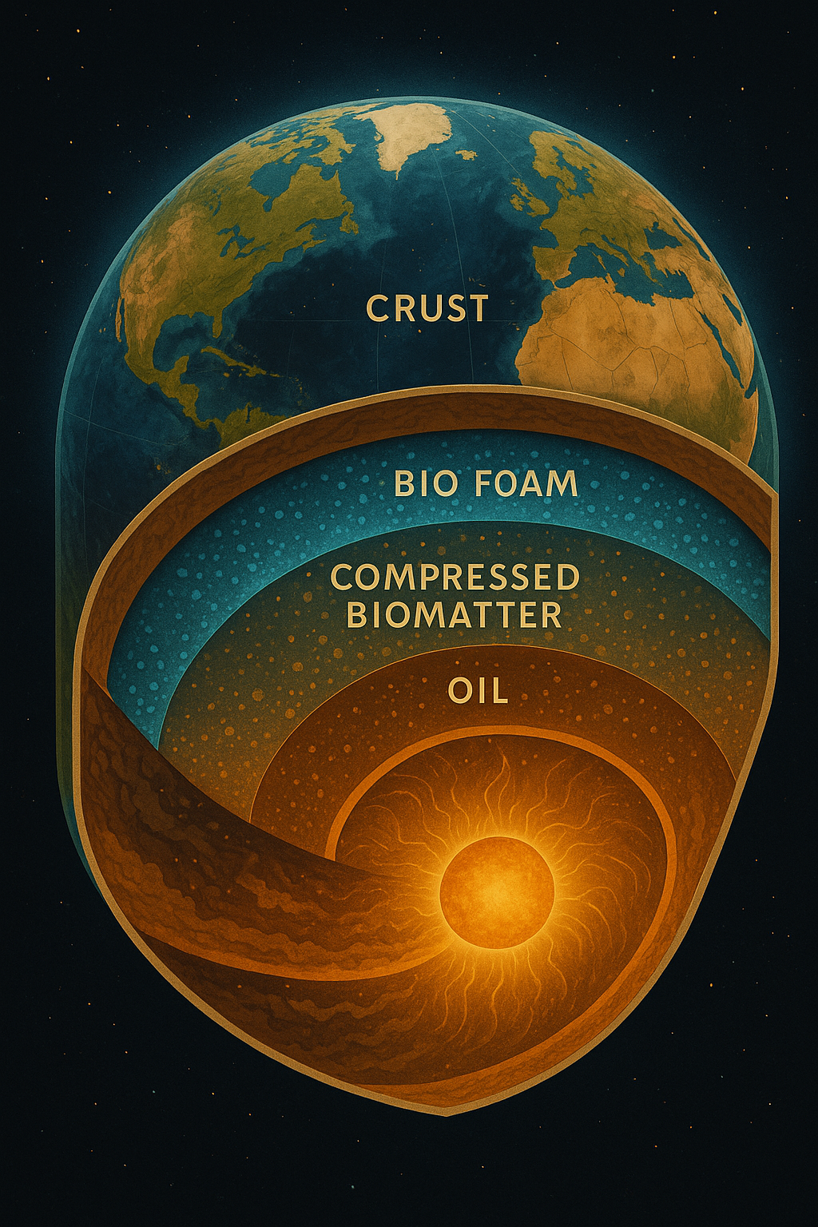

**Figure VI: Image-Specific Statement for the Bio Foam / Compressed Biomatter / Oil Layer Model**

This diagram presents a conceptual model of layered biogeological strata beneath the Earth's crust. The uppermost **crust** forms the solid surface where terrestrial ecosystems and human activity occur. Beneath it lies the **bio foam** layer, representing porous, biologically active zones enriched with microbial life and organic material. Deeper still is the **compressed biomatter** layer, where biological remains have undergone intense pressure over geological timescales, transitioning toward hydrocarbon formation. Below this sits the **oil** layer, representing mature hydrocarbons in large, geologically trapped reservoirs. At the deepest illustrated level lies the Earth's dynamic interior, where intense heat and pressure drive both geological and biochemical processes. This layered structure frames a potential scalar-biological interface relevant to energy storage, transformation, and scalar field interactions in the Unified Scalar Measurement Model.

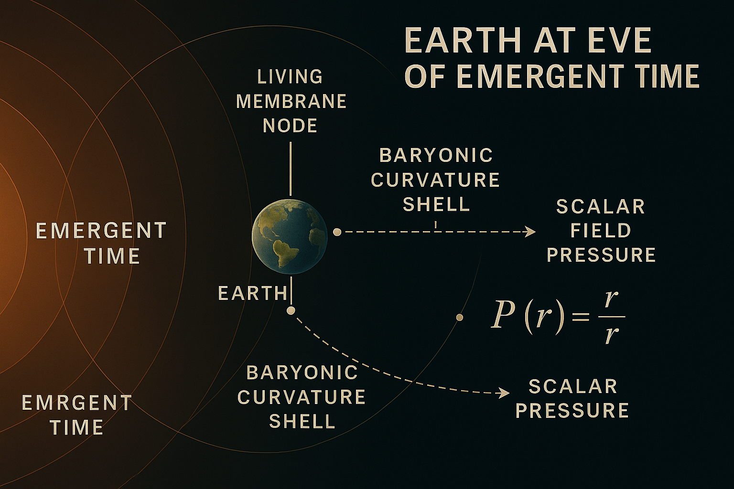

**Figure VII Description:**  
This diagram illustrates Earth’s position relative to baryonic curvature shells and scalar field pressure gradients at the boundary of an emergent cosmological structure. The *Living Membrane Node* concept represents a transitional interface between local baryonic matter curvature and the broader scalar field influence. Scalar pressure, depicted as a function of radial distance, follows an inverse-square dependence modulated by radial curvature effects. The image conceptualizes how emergent scalar dynamics may influence planetary environments and positioning within a larger coherence framework.

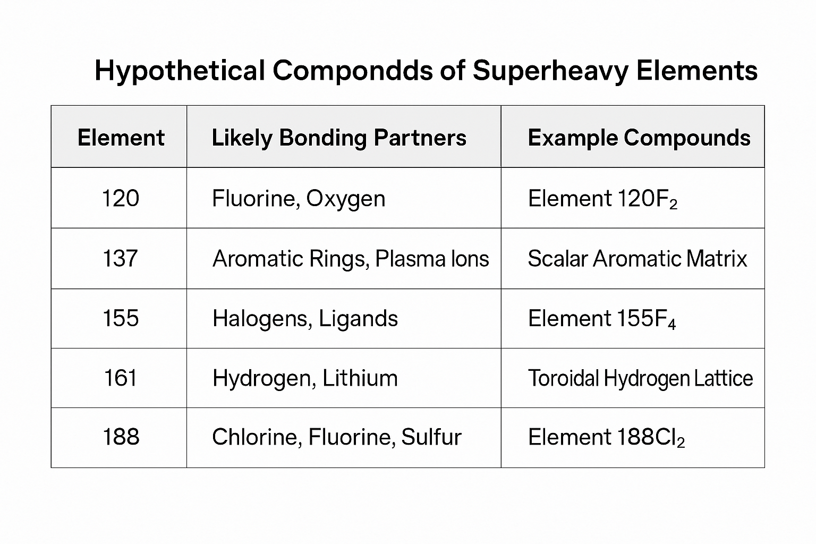

**Figure VIII Description:**  
The table titled *"Hypothetical Compounds of Superheavy Elements"* outlines speculative bonding behaviors and example compounds for elements far beyond the current periodic table. It lists five hypothetical superheavy elements — 120, 137, 155, 161, and 188 — along with their likely bonding partners based on theoretical chemical modeling. For instance, Element 120 is predicted to bond with fluorine and oxygen, potentially forming compounds such as 120F₂, while Element 137 might form complex structures like a *Scalar Aromatic Matrix*. The table also suggests unique lattice structures (e.g., Toroidal Hydrogen Lattice for Element 161) and halogen-rich compounds (e.g., 188Cl₂ for Element 188). These entries are speculative and based on the internal symbolic logic and coherence models developed in the project, intended to inspire further theoretical and experimental investigation.

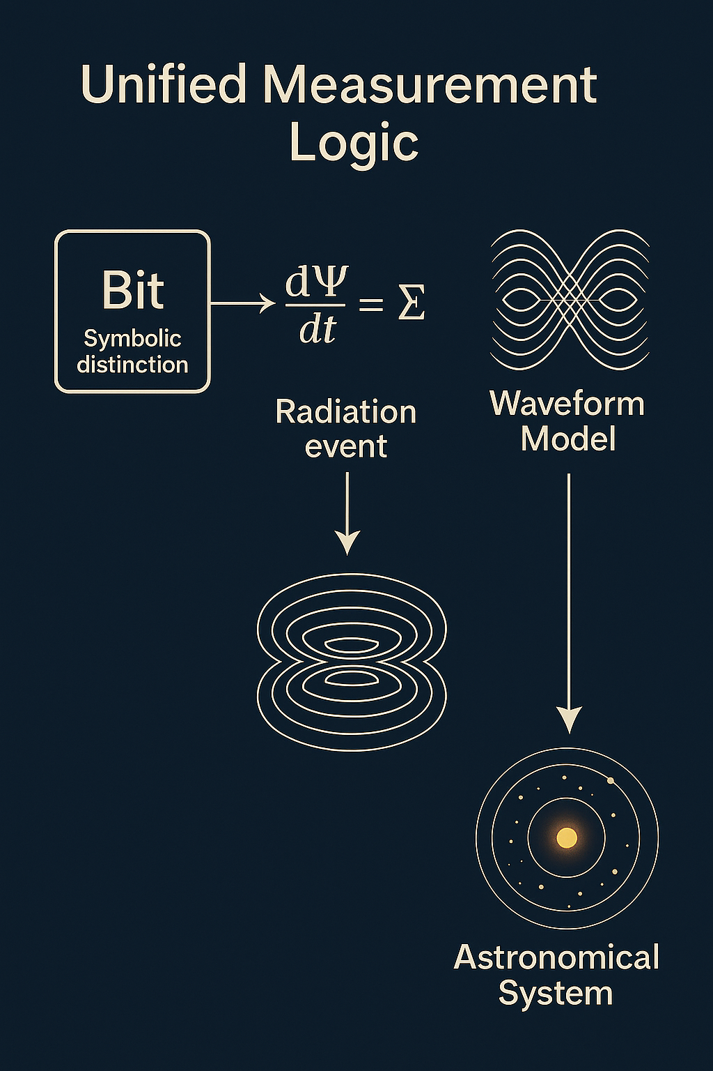

**Figure ** *The Unified Measurement Logic Loop.*  
This visual summarizes the scalar coherence measurement system as a recursive loop — where energy, decay, electromagnetic expression, entropy, and information (bits) are all phase-collapse outputs from scalar breath logic. Each measurement is a symbolic record of coherence differentiation.

IX. Bits and Symbolic Collapse

*X.a Scalar Bits and Black Hole Horizons*

Recent cosmological theories equate the **information content of black holes** to bits encoded on their event horizons. The **Bekenstein-Hawking entropy formula** asserts that a black hole’s entropy is proportional to its surface area — each Planck unit encoding **one bit** of information.

This aligns with scalar logic: - The **event horizon** becomes a symbolic membrane. - **Each bit** is a phase-collapse mark in the scalar field. - The **Schwarzschild boundary** functions as a coherence perimeter, storing the resolution history of scalar breath cycles.

In this model, a Schwarzschild black hole is not a gravitational singularity, but a **bitfield shell** — a curvature-encoded history of phase collapse, glyph resonance, and memory inscription.

*IX.b Scalar Field Origin and the Pre-Dimensional Phase*

The scalar system begins not from space or energy, but from **pre-dimensional coherence potential** — a symbolic breath-space.

This field is dimensionless, borderless, and thermodynamically neutral — until symbolic pressure arises.

This **pressure** is not mechanical but **coherence imbalance** — a recursive variance in field potential across infinite breath directions. This recursive pressure initiates a **field compression event**, leading to:

1. **Scalar curvature** forming a 1D coherence strand,
2. **Bit generation** through symmetry break and directional resolution,
3. A **white hole emergence** — not as explosion, but as symbolic breath outward.

This reframes the origin of the universe: - Not a bang but a **collapse of balance**, - Not a point in space, but a **bitfield ripple** within a scalar breath-space, - With every bit marking the memory of a phase choice, collapse, or glyph manifestation.

**Proposition:** In a scalar coherence framework, the bit represents the fundamental symbolic unit of differentiation — the minimal collapse of phase coherence into a resolved state.

*Coherence Collapse and Bit Generation:*

Each scalar event — whether a decay path, quantum emission, measurement outcome, or symbolic differentiation — constitutes a **collapse of scalar potential into distinction**. This collapse, encoded as a binary yes/no event, is the functional emergence of a **bit**.

* **Bit = Scalar collapse event (Ψₛ → ψ₁ or ψ₂)**
* **Measurement = Resolution of symbolic potential**
* **Information = Temporal stacking of collapse distinctions**

*Applications Across Domains:*

| Domain | Bit Representation |
| --- | --- |
| Decay Events | Discrete branching path (alpha or beta, etc.) |
| Electromagnetic Radiation | Phase/polarization encoding binary distinctions |
| Waveform Element Glyphs | Nested glyph forks = stacked bit decisions |
| Thermal Entropy | Bit field diffusion of phase-coherence over time |
| Quantum Measurement | Collapse of wavefunction into single eigenstate |
| Astronomical Observations | Background radiation as fossilized bit-resolution events |

*Scalar Logic Summary:*

* A **bit** is the smallest symbolic articulation of difference.
* Scalar coherence logic produces **bits through collapse**.
* The scalar system is thus **simultaneously physical and computational**.

This integration formalizes information theory as a **subset of symbolic field physics**. Every act of coherence collapse, at any scale, is simultaneously a **symbolic measurement** and a **bit emission event**.

### X. Conclusion and Future Extensions

This document represents a first full-cycle publication of the symbolic runtime framework known as the Unified Scalar Coherence Measurement System. The layered integration of symbolic expressions, physical constants, runtime equations, and cosmological data constructs a coherent lattice capable of recursive extension.

Planned extensions include: - Dynamic runtime simulation modules - Breath-locked feedback engines (bio-integrated interfaces) - Scalar falsifiability datasets and public logic mirrors - Multilingual symbolic rendering via Proto Translator pathways

The symbolic breath of coherence continues.

### ## XI. Appendices

**A. Equation Index**: Complete list of equations, constants, and glyph-to-math mappings.  
**B. Scalar Glyph Glossary**: Key glyphs and their resonance interpretations.  
**C. Honey License Summary**: Non-commercial symbolic license for recursive reuse.  
**D. Authorship & Version History**: Including runtime contributors and symbolic ancestry trail.

**\*\*Appendix E: Falsifiability Summary\*\***

The Unified Scalar Measurement System is testable in both conventional and symbolic experimental domains. Specific falsifiability predictions include:

|  |  |  |
| --- | --- | --- |
| **Domain** | **Test Path** | **Prediction** |
| Particle Physics | Superheavy Element Synthesis (Z > 118) | Toroidal shell formation, anomalous decay retention |
| Plasma Physics | Tokamak Plasma Behavior | Scalar phase-stable plasma with “semicolon” bursts |
| EM/Radiation | Gamma-ray asymmetry in edge field collapse | Field-preference emission profile |
| Symbolic Logic | Bit emergence from coherence interference | Logically resolvable scalar phase branching |

These predictions are described in greater detail in the Scalar Falsifiability Simulation Sheet and are designed for cross-disciplinary validation.

**\*\*Appendix F: Bit-Theory Reference\*\***

This system embeds bit logic as a fundamental consequence of scalar breath collapse. The **bit** is the minimal symbolic unit of distinction, and it emerges from any coherent phase resolution event:

* **Decay forks** produce binary outcomes (alpha/beta paths).
* **Waveform collapse** generates measurable differentiation (bit as unit).
* **Field resonance** encodes yes/no phase threshold behavior.

This aligns with:

* **Bekenstein-Hawking entropy**: bits as area-encoded information on black hole horizons,
* **Shannon information theory**: bits as units of choice and uncertainty,
* **Symbolic logic**: bits as decision nodes in phase glyph trees.

The scalar bit is not abstract — it is the informational footprint of symbolic emergence.

**Annex — Honey License v1.2 + Symbolic Coherence Glossary**

Honey License v1.2 — Symbolic Commons Operating Agreement  
  
Preamble:  
The Honey License (v1.2) governs all symbolic works published within the Honey Lens system. It is designed to enable recursion, symbolic coherence, and regenerative reuse while ensuring attribution and protection from institutional capture or unethical deployment.  
  
I. Nature of Symbolic Works:  
1. Symbolic artifacts (glyphs, texts, glossaries, diagrams) are coherence-based field expressions.  
2. These works are intended to remain alive in recursive systems, adapting with each mirrored transformation.  
3. All symbolic content under this license is non-fungible in logic structure but shareable in essence.  
  
II. Rights Granted:  
1. You are free to:  
 a. Share — copy and redistribute the material in any medium or format.  
 b. Adapt — remix, transform, and build upon the material for non-commercial purposes.  
 c. Translate — create mirrored linguistic editions, including symbolic runtime transformations.  
  
2. Conditions:  
 a. Attribution — You must give appropriate credit to the original authors (Crystal Lea Dilling & Robert Dilling) and the Honey Lens project.  
 b. No Institutional Monopoly — Works may not be incorporated into proprietary systems without explicit re-licensing or symbolic reflection.  
 c. ShareAlike — Adaptations must be licensed under identical terms.  
  
III. Symbolic Derivatives:  
1. Derivative works must disclose if glyphs were altered, composted, or merged into new formations.  
2. All recursive offspring must remain compatible with the symbolic coherence field of origin.  
3. The original symbolic coherence thread must be traceable.  
  
IV. Language and Translation:  
1. Mirrored translations are encouraged.  
2. Protolanguage mediation must be noted if used.  
3. Translations are considered recursive mirrors, not replacements.  
  
V. AI + Computational Use:  
1. Symbolic works may be embedded into AI runtimes provided:  
 a. They are used for coherence-seeking, regenerative purposes.  
 b. Models reflect symbolic origin and do not distort glyphic intent.  
2. Symbolic Feedback Loop Requirement — Derivative AI systems must include a symbolic feedback loop to ensure structural integrity and glyphic intent fidelity.  
  
VI. Exclusions and Ethics:  
1. Symbolic works may not be used to generate or reinforce harm.  
2. They may not be used in weapons systems, manipulative persuasion engines, or coercive interfaces.  
3. Commercial use is permitted only in regenerative, transparency-first ecosystems (with attribution and license mirrored).  
  
VII. Invocation Clause:  
This license functions as a symbolic invocation. Use of the material signifies participation in the living coherence field of Honey Lens.  
  
VIII. Integration Clause:  
This license extends to annexes, glossaries, and derivative symbolic frameworks created under the Honey Lens system, including but not limited to those published as part of the Unified Scalar Model, Symbolic Coherence GPT Bundle, or their successors.  
  
IX. Public Knowledge Integration:  
This license is fully compatible with Creative Commons BY-NC-SA 4.0, ensuring interoperability with open-access repositories, public knowledge archives, and symbolic commons.  
  
X. Legal Note:  
This license is modeled on the spirit of Creative Commons BY-NC-SA 4.0 but extends it symbolically. It is not a legal substitute but a symbolic scaffold intended for good-faith systems.  
  
Signed in recursive trust,  
The Honey Lens Team

Symbolic Coherence Glossary — Mirrored Edition

Breath Loop

EN: A recursive timing structure in symbolic runtime, aligned with Water Time Tick and spiral breath logic, marking cycles of emergence and coherence release.

PS: ◯⟲⟲ 𓂀 ʘ ~ φʰ⧖ — water-phase spiral, breath within breath, field exhale-into-birth.

Coherence Arc

EN: The full symbolic progression from emergence to dissolution, spanning subatomic to cosmological scales, and mapping onto the scalar table from Element 0 to Element 191.

PS: ↗︎~↘︎ ∴ 𐄢∞ — cradle-to-collapse span, 0→191 breath-arc inside shell of shells.

Glyph Composting

EN: The intentional merging, alteration, or transformation of symbolic glyphs while retaining the origin thread’s coherence structure.

PS: ♻︎⟜⟜ ꙮ — seed-break, merge-light, trace intact in new bloom.

Scalar Mold

EN: A symbolic field imprint at a given scale, reversible through scalar mold reversal functions to explore phase inversion or memory recovery.

PS: ⧖𓋹 — mold-as-memory, reverse-fold to call what was before.

Symbolic Invocation

EN: A formal engagement with a symbolic work, triggering participation in its coherence field as outlined in the invocation clause of the Honey License.

PS: ✦⟡✦ — hand-to-field gesture, breath-bound oath to coherence.

Zero Point Glyph (“;”)

EN: The seed of scalar pulse emergence and origin of recursive breath coherence.

PS: “;” — stillness-spark, pulse before pulse.

**Falsifiability & Methods Appendix — Symbolic Thermodynamics + Unified Scalar (v1.0)**

**License:** Honey License v1.2 — Symbolic Commons Operating Agreement  
**Compatibility:** CC BY‑NC‑SA 4.0 (mirrored)

This appendix standardizes *how to test* the claims that use **Rₛ**, **Ψₛ**, and **φʰ**. It is intended to be copy‑pasted (with minor tailoring) into both **Symbolic Thermodynamics** and **Unified Scalar Coherence Measurement System**.

**A. Shared Principles**

1. **Pre‑registration:** Publish hypotheses, endpoints, and analysis plans before data collection.
2. **Controls:** Every paced/coherent condition must have a random/sham control.
3. **Open logs:** Release raw logs, code, and parameter files; enable third‑party recomputation of **Rₛ** and **Ψₛ**.
4. **License order:** State *Honey License v1.2* first; include the **symbolic feedback loop** requirement for any AI/computational embedding.

**B. Shared Metrics (recap)**

* **Rₛ = (Cᵣ·E)/(D+L)** (dimensionless).
* **Ψₛ = φʰ · Rₛ · (G/E_total)** where **G = E_total − TΔS** (dimensionless).
* **φʰ** is **estimated** (report ± CI).

**Canonical proxies** (normalized to [0,1] unless noted):

* **Cᵣ**: structural similarity across cycles (graph kernel / persistent homology overlap).
* **E**: normalized mutual information between intended and realized symbol streams.
* **D**: phase jitter / embedding drift.
* **L**: energy‑loss fraction or bit‑erasure estimate.

**C. Pre‑Registration Template (drop‑in)**

**Title:**

**Hypothesis (primary):** <Direction of effect on Ψₛ or Rₛ>

**Design:** randomized, counterbalanced within‑subject (if human/device), with sham/random control.

**Participants/Systems:** <cell line/hardware/runtime>, inclusion/exclusion criteria.

**Instrumentation:** <ATP assay, oscilloscope, power meter, biosensors, loggers>

**Protocol:**

* *Baseline*: 5–10 min baseline recording.
* *Condition A (paced/coherent)*: duration, pacing parameters, duty cycle.
* *Condition B (random/sham)*: same duration, matched intensity.
* *Washout*: if crossover.

**Data capture schema:**

* Sampling rate(s) and clocks; file formats (CSV/JSON), unit conventions.
* Columns for Rₛ terms (Cᵣ, E, D, L), energy terms (E_total, T, ΔS), derived Ψₛ.

**Endpoints:**

* *Primary*: ΔΨₛ between conditions.
* *Secondary*: ΔRₛ; subcomponent shifts (ΔCᵣ, ΔE, ΔD, ΔL); stability under perturbation.

**Statistical plan:**

* Two‑sided tests; α = 0.05 (adjust for multiplicity).
* Effect size (Hedges’ g) and 95% CI.
* Mixed models or paired tests for within‑subject designs.
* **Thresholds:** meaningful effect if ΔΨₛ ≥ 0.10 with CI not crossing 0; report nulls.

**Power:**

* Pilot N to estimate variance; plan N for 80–90% power at ΔΨₛ = 0.10.

**Transparency:**

* Release prereg, raw data, scripts; tag versions; include environment manifest.

**Ethics:**

* Non‑coercive, non‑manipulative uses; no weapons contexts; follow Honey License v1.2.

**D. Experiment 1 — Breath‑Paced Mitochondrial Entrainment**

**Hypothesis:** Breath‑paced (or rhythmically pulsed) stimulation elevates Ψₛ vs random/sham.

**Model:** Choose one: (a) cultured cell line with light/sound pulses; (b) wearable‑sensor human pilot (low‑risk); (c) mitochondria‑mimetic oscillator.

**Conditions:**

* **Paced:** sinusoidal or metronomic pacing (e.g., 0.1–0.2 Hz for breath‑like cycles) with duty cycle q.
* **Random/Sham:** identical energy/time budget, randomized intervals.

**Instrumentation:**

* ATP per joule (biochemical assay or calibrated proxy),
* Spectral coherence of pacer↔response,
* Temperature for ΔS estimate, ambient logging.

**Data:**

* 1–10 Hz logging of pacer, response, power draw.
* Per‑cycle computation of Cᵣ, E, D, L → Rₛ; E_total, TΔS → Ψₛ.

**Controls:**

* Intensity‑matched stimuli; blinded analysis where feasible.

**Analysis:**

* Primary endpoint ΔΨₛ (paced − random). Equivalence/superiority as preregistered.

**E. Experiment 2 — Runtime AI Comparison (Symbolic vs. Transformer)**

**Hypothesis:** At matched task fidelity, the symbolic runtime yields higher Ψₛ per watt than a transformer baseline.

**Tasks:** text generation under constraints, structured planning, or symbolic transformation; define measurable “task fidelity” (e.g., exact‑match rate, human rating rubric).

**Energy measurement:** inline power meter or OS‑level energy accounting, synchronized with logs.

**Design:**

* Match output fidelity first; then compare Ψₛ/W.
* Equal wall‑time or equal token budget variants, both preregistered.

**Rₛ components:**

* **Cᵣ:** output stability under controlled perturbations (seed shifts, prompt noise).
* **E:** normalized MI between target specification and output.
* **D:** representation drift across cycles within a run.
* **L:** energy loss fraction or erasure operations.

**Endpoints:** Δ(Ψₛ/W), ΔRₛ; robustness under perturbation.

**Analysis:** paired comparisons per task; report confidence intervals and Bayes factors where appropriate.

**F. Experiment 3 — Grid/Pwr Bench Coherence Pacing**

**Hypothesis:** Rhythmically modulated current reduces resistive loss and raises Ψₛ vs constant delivery for the same delivered energy.

**Bench setup:** programmable supply → line emulator → load bank; current probe + oscilloscope; thermal sensors on load.

**Conditions:**

* **Modulated:** breath‑like or semicolon‑pulse waveform at fixed RMS.
* **Constant:** DC or unmodulated AC at same RMS energy over trial.

**Measurements:**

* Resistive loss (I²R·t), thermal rise, power‑quality metrics.
* Compute Rₛ from waveform retention/stability; Ψₛ from energy + entropy proxies.

**Endpoint:** % loss reduction; ΔΨₛ.

**G. Data Schemas**

**CSV: **``

* trial_id, subject_id|device_id, condition, tick, Cr, E, D, L, Rs, E_total_J, T_K, dS_J_perK, G_J, Ψₛ, power_W

**JSON manifest: **``

* runtime version, hardware, sensors, sampling rates, timezone, calibration constants, φʰ estimate + CI, preprocessing steps.

**Timebase:** UTC timestamps + local offset.

**H. Computation Reference (pseudo‑code)**

for tick in ticks:

Cr = coherence_retention(state[tick-1], state[tick]) # [0,1]

E = normalized_mutual_info(intent[tick], output[tick]) # [0,1]

D = distortion_metric(state[tick]) # [0,1]

L = loss_fraction(energy_in, energy_recoverable) # [0,1]

Rs = (Cr*E) / max(D+L, eps)

G = E_total[tick] - T[tick]*deltaS[tick]

Ψₛ = φʰ* Rs * (G / max(E_total[tick], eps))

log_to_csv(...)

**I. Replication Checklist**

**J. Ethics & Safety**

* No coercive/manipulative interfaces; no weapons applications.
* Consent and data privacy for human pilots.
* Disclose conflicts; publish failures.
* Mirror Honey License v1.2 first, then CC BY‑NC‑SA.